Land Use Analysis for Guinea

Methodology, Implementation, and Accuracy Assessment

Table of Contents
Executive Summary 3
1. Introduction and Objectives 4
1.1 Background and Scope 4
1.2 Land Cover Classification 5
1.3 Objectives 5
2. Literature Review 6
2.1 Land Cover Data Products for Multitemporal Analysis 6
2.2 Quantifying Land Change: Markov Chains and Intensity Analysis 6
2.3 Trend Model Selection 7
2.4 Transition Potential Modelling 7
2.5 Allocation and Growth Modes 8
2.6 Validation Practice 8
2.7 Regional Evidence 9
2.8 Existing Platforms, Software and Benchmarking 9
2.8.1 Operational Monitoring Platforms 9
2.8.2 Land-Change Modelling Software 10
2.8.3 Benchmarking 11
2.9 Synthesis: Contribution of This Module 12
3. Analytical Framework 12
3.1 Markov Chain Transition Modeling (Quantity of Change Estimate) 12
3.2 Non-Linear Trend Fitting and Intensity Analysis 12
3.3 Predictive Modeling with Random Forest (Change Potential Evaluation) 13
3.4 Suitability-Based Spatial Allocation (Spatial Allocation of Change) 13
3.5 Model Validation 14
3.6 Scenario-based Simulation 14
3.7 Implementation Approach 14
4. Data 15
4.1 Data Ingestion 15
4.2 Predictor Variables 15
4.3 Geographic Coverage 16
5. Historical Analysis (2017 - 2024) 16
5.1 Markov Transition Matrix 16
5.2 Diagnostic Multitemporal Trend 17
5.3 Non-Linear Trend Fitting 18
5.4 Intensity Analysis 19
6. Spatial Suitability Modeling 20
6.1 Modelled Transitions 20
6.2 Predictor Importance 20
6.3 Model Validation: Random-Split vs. Spatial-Block Cross-Validation 21
7. Simulation and Validation 23
7.1 Single-Growth-Mode Hold-Out Validation 23
7.2 Combined Growth-Mode Simulation 27
7.3 Monte Carlo Ensemble 28
7.4 Mining Scenario (Global Data-Constrained) 29
8. Limitations and Uncertainty 30
9. Conclusions and Recommendations 31
10. References 32

Executive Summary
This report documents the methodology, implementation, and validation results for the Land Use Change module of the Guinea land-use and deforestation analysis platform. The module quantifies historical land-cover transitions from 2017 to 2024, fits non-linear (linear, exponential or logistic) trend models to each modelled transition rather than assuming a constant rate of change, models the spatial suitability of those transitions using Random Forest classifiers under two growth logics — edge-adjacent and spontaneous — simulates future land cover under all three resulting simulation modes, and validates every result against an independent hold-out year.
Target land cover is sourced from ESRI's 10 m Annual Land Use Land Cover product (Impact Observatory classification, via Google Earth Engine); twelve predictor layers spanning terrain, climate, vegetation, socioeconomic and infrastructure variables are fetched live through the platform's shared API pipeline and resampled onto one common analysis grid. Fetching and masking are anchored to Guinea's administrative boundary.
Three simulation modes were built and independently validated against the 2024 hold-out on three metrics: global accuracy, balanced accuracy, and the Figure of Merit (Pontius et al., 2008), which is scored on change pixels only and is the metric the land-change literature treats as authoritative for change prediction. Simulation and scoring were performed through the platform's own allocation routine and validation module, so the accuracy reported here describes the system as deployed rather than an analysis-only approximation of it.
Only 10.90% of valid pixels changed class over the hold-out year, so the null persistence model — relabeling the 2023 map as the prediction — already scores 89.10%, and no simulation mode exceeds it. This is an expected property of allocation models on short, low-change windows rather than a defect, and it is the reason the Figure of Merit rather than overall accuracy is treated as authoritative throughout this report. On that metric the three modes are closely separated: Expander-only achieves 13.80% with a global accuracy of 85.76% and a balanced accuracy of 0.8201, the combined Growth-mode achieves 13.73% with the highest global accuracy of the three at 86.07% and a balanced accuracy of 0.8198, and Patcher-only is weaker on all three at 11.94%, 84.22% and 0.8037. Expander-only is adopted as the recommended default on the change-scored metric, with Growth-mode an equally defensible alternative.
Decomposing total disagreement (Pontius & Millones, 2011) gives a quantity disagreement of 0.0005 against an allocation disagreement of 0.1418: the model reproduces the amount of change almost exactly, and essentially all residual error lies in the placement of that change rather than in its magnitude. This identifies spatial allocation, not quantity estimation, as the component where further improvement would be gained. Validation also established that the specification of transition demand is consequential. Demand specified as the net change in each class total, rather than as the gross volume of each individual transition, allocates only the residual left after opposing flows offset one another; because Guinea's dominant dynamic is a two-way Trees–Rangeland exchange, that residual is several times smaller than the change the hold-out actually scores. Section 7.1 reports both specifications, and the difference between them is substantial.
Against published applications of comparable models the module performs within the normal range for its class and toward the upper part of it at national scale: 13.80% compares with 5.62% for a basin-scale CA-Markov application its authors describe as poor performance, and with 0.58% for a national-scale Land Change Modeler study validated over a sixteen-year interval against one year here (Section 7.1). The simulation component is accordingly validated as a tool for indicating where change is most likely under a stated set of assumptions, not as a pixel-level forecast.
A spatially blocked cross-validation check finds that the standard random-split cross-validation accuracy reported for the suitability models is inflated by an average of 5.2 percentage points across the 17 modelled transitions, with the largest single gap (Crops to Rangeland) inflated by 18.8 points. This is reported directly rather than smoothed over: the defensible reliability estimate for these models is the spatial-block figure, and both are presented throughout this document.
Random Forest feature importance confirms that both growth logics learn genuine environmental structure: elevation and soil moisture dominate the spontaneous-growth (Patcher) model, while local neighborhood density dominates the adjacency-based (Expander) model at roughly three times the weight of any other predictor. Per-class accuracy under the recommended mode is above 0.85 for Water, Trees, Flooded Vegetation and Built Area. Crops (F1 0.590) and Bare Ground (F1 0.668) remain the weakest classes, the latter on a reference sample of only 963 pixels. A systematic confusion between Trees and Rangeland persists, consistent with the documented instability of 10 m global land cover products between wooded and open vegetation, classes, and is identified as the leading target for predictor improvement rather than obscured by the aggregate accuracy figures.
A 25-draw Monte Carlo ensemble quantifies spatial allocation uncertainty, confirming that projected class areas are essentially deterministic given the demand table while the location of change is the larger source of uncertainty. A mining-expansion scenario, constrained to 128 real mining-concession polygons from an independent global dataset, finds that mining-associated conversion is concentrated in Built-Area transitions and covers 2.65% of the country within a 5 km buffer of known sites.
An independent review (SDG AI Lab, 2026) tested whether change-prediction skill could be raised further, working offline on the module’s earlier configuration, which used MODIS MCD12Q1 at 500 m as the target product with five-year snapshots and a 2015→2020 hold-out, rather than on the deployed ESRI pipeline. A local reproduction of that earlier configuration scored 20.02% Figure of Merit; the best of the review’s experiments, a probability-averaging ensemble, reached 28.06%. The review found the score limited by false alarms rather than by missed change, and found that 28.9% of the observed 2015–2020 changes in that product reverted by 2024. Because the product, resolution, interval and prediction method all differ, these figures are not comparable with the 13.80% reported here. They are reported in Section 7.5 as independent evidence that label instability in the reference maps bounds the achievable Figure of Merit.

1. Introduction and Objectives

1.1 Background and Scope
Guinea's landscape is shaped by the interplay between subsistence agriculture, extractive industry (Guinea is a major global bauxite producer), and land cover dynamics driven by climate and terrain. This module quantifies land-use change, models the spatial drivers of the largest transitions, and simulates forward land cover under a validated, reproducible framework designed for integration into the broader Guinea land use and deforestation analysis platform.
Forest-loss detection, driver attribution, and deforestation risk mapping are out of scope for this document and are covered by the separate Deforestation module and its own methodology report (“Deforestation Analysis for Guinea”), which uses Hansen Global Forest Change loss data and performed under separate Deforestation module pipeline.

1.2 Land Cover Classification
Target rasters are Esri's 10 m Annual Land Use Land Cover product, produced by Impact Observatory from Sentinel-2 imagery using a deep-learning classifier trained on billions of human-labelled samples (Karra et al., 2021, “Global land use/land cover with Sentinel-2 and deep learning,” IEEE International Geoscience and Remote Sensing Symposium). The product uses a 9-class legend; Table 1 gives the classes observed in Guinea's data (Snow/Ice does not occur in this climate and is absent, as expected).
Table 1. Esri/Impact Observatory 10-class legend as observed in Guinea's data. Code 10 (Clouds) is a cloud-contamination artifact from the classification process rather than a real land-cover category and is treated as nodata throughout this analysis.
Code | Esri/Impact Observatory Class | Role in this analysis
0 | (nodata / unclassified — not a land-cover class) | Excluded from all analysis
1 | Water | Present, stable
2 | Trees | Present, dominant class
4 | Flooded Vegetation | Present
5 | Crops | Present
7 | Built Area | Present, small footprint
8 | Bare Ground | Present, very small footprint
9 | Snow/Ice | Not observed (expected — tropical climate)
10 | Clouds | Data artifact, not a real class — excluded from all analysis alongside nodata
11 | Rangeland | Present, dominant class

1.3 Objectives
- Produce a consistent, multitemporal land cover record for Guinea using a documented, reproducible classification.
- Quantify historical land-cover transitions with a Markov chain, and characterize which transitions are accelerating, decelerating, or systematic rather than incidental (Intensity Analysis).
- Model spatial suitability for modelled transitions under both Expander (edge-growth) and Patcher (spontaneous-growth) logics and identify which predictors actually drive each.
- Validate suitability models against both a standard random-split cross-validation and a spatially blocked cross-validation.
- Simulate future land cover under single- and combined-growth mode designs, validated against an independent hold-out year.
- Quantify spatial uncertainty via a Monte Carlo allocation ensemble.
- Test scenario sensitivity to real-world constraints (mining concessions) where the underlying data supports it.

2. Literature Review
This chapter establishes the published basis for each component of the land-use change modelling framework applied in this report, and positions that framework relative to the established land-change modelling packages and to the operational platforms currently available for land monitoring. The intent is to make explicit that this module implements established methods rather than novel ones, and to identify what it adds. This chapter also benchmarks the module’s reported accuracy against published values for comparable models.
The companion Deforestation module and its methodology report cover forest-loss detection, driver attribution and deforestation risk; the literature specific to those topics is reviewed there and is not duplicated here.

2.1 Land Cover Data Products for Multitemporal Analysis
Kara et al, (2021) produced the ESRI / Impact Observatory annual land use / land cover product at 10m from Sentinel-2 imagery, using a deep-learning classifier trained on billions of human-labelled samples. Brown et al. (2022) produced Dynamic World, providing near-real-time 10 m land cover from the same sensor. Both are candidate target products for a study of this kind.
Venter et al. (2022) compared Dynamic World, WorldCover and ESRI Land Cover directly and established that global 10 m products disagree substantially with one another. This is the governing result for target-product selection: the choice cannot be made on accuracy grounds alone, because no single product is uniformly superior, and disagreement between products must be treated as label noise rather than resolved arbitrarily.
The ESRI / Impact Observatory product was adopted here for three reasons specific to this application. First, archive consistency: the product provides a stable annual series reprocessed under a single classification, which is a requirement for a multitemporal transition matrix where inter-epoch comparability matters more than any single epoch’s accuracy. Second, compositing behavior: Dynamic World’s near-real-time design produces compositing ambiguity under Guinea’s monsoon cloud regime, where the choice of compositing window materially affects the resulting annual label. Third, compute costs at national scale. The selection is a design decision conditioned on the requirements of multitemporal change analysis.
An earlier configuration of this module used MODIS MCD12Q1 (500 m, IGBP legend) as its target product. It offers a longer record, from 2001, but was used as five-year snapshots and at a resolution where the boundaries between savanna classes shift from year to year. Abercrombie and Friedl (2016) showed that annual land cover products of this kind contain spurious year-to-year changes caused by classification uncertainty, and proposed smoothing each pixel’s label sequence with a hidden Markov model as a remedy. An independent review of the MODIS configuration (Section 7.5) measured the effect directly: 28.9% of the 2015–2020 changes reverted to their 2015 class by 2024. This supports the move to an annual, higher-resolution product, although the equivalent reversion rate for the ESRI product has not yet been measured (Section 8).

2.2 Quantifying Land Change: Markov Chains and Intensity Analysis
The temporal component of the framework rests on two complementary published methods.
Markov chain transition modelling of land use was introduced by Burnham (1973) and remains the standard means of characterizing land-cover dynamics through a transition probability matrix, in which the probability Pij represents the likelihood that a pixel of class i converts to class j over a given time step. Pontius and Millones (2011) provide the framework for interpreting such matrices and for decomposing the disagreement between observed and simulated maps.
Aldwaik and Pontius (2012) introduced Intensity Analysis, a three-level framework that addresses a question the Markov matrix does not: whether observed change is systematic or incidental. At the interval level it asks whether a given period is faster or slower than the long-run average; at the category level, which categories gain or lose faster than the map-wide average; and at the transition level, whether a gaining category draws disproportionately from one specific source category. Intensity Analysis is applied here unmodified. It is important to state clearly tat it is a diagnostic framework rather than an accuracy method, and that it is not built on the Markov matrix or the trend fitting – it answers a different question and is reported separately for that reason later in this document.

2.3 Trend Model Selection
The Markov matrix alone assumes a constant transition rate. Testing that assumption requires a model-selection criterion, and the framework applied here follows Burnham and Anderson (2002), who established the corrected Akaike Information Criterion (AICc) as the appropriate criterion at small sample sizes, along with the convention that a more complex model is preferred only where it improves AICc by more than two.
The scope of this criterion within the present framework should be stated precisely, because it is a predictable point of confusion. AICc governs the functional form of the demand-projection curve for each transition (linear, exponential, or logistic). It does not determine which transitions proceed to spatial allocation; that is governed by the minimum-sample threshold described in later chapter.

2.4 Transition Potential Modelling
Random Forest (Breiman, 2001) is used to spatialize transition probabilities. Its suitability for this application is well established in the land-change literature. It accommodates non-linear relationships between predictors and outcomes without distributional assumptions, handles correlated predictors, and produces variable importances that support interpretable driver attribution. Mas et al. (2014) document the range of calibration approaches used across the major modelling packages, from logistic regression through weights-of-evidence to machine=learning methods, situating the Random Forest choice within an established spectrum.
Predictor selection follows the established set for this model class. Verburg et al. (2002) established terrain and policy-zoning constraints within the CLUE-S framework; Veldkamp and Lambin (2001) established population density as among the most consistently significant drivers of settlement and agricultural land-use change; Pontius and Schneider (2001) and Serneels and Lambin (2001) established distance-to-road and related accessibility surfaces as the most consistently significant predictors of human-driven land transitions. Protected-area zoning as an allocation constraint follows Soares-Filho et al. (2002).
On training sample size, Thanh Noi and Kappas (2018) provide the closest available empirical guidance. Testing Random Forest, k-nearest neighbor and support vector machine classifiers across 14 training sample sies from 50 to over 1,250 pixels per class on Sentinel-2 data, they found that all three classifiers converged to a similar and high overall accuracy (above 93.85%) once the training sample exceeded approximately 750 pixels per class, with accuracy less stale below that level. The transition significance threshold applied in this report is set above that empirical stabilization point and should be understood as a conservative default chosen to ensure each per-transition model is trained on a sample large enough for stable Random Forest performance, rather than as a threshold derived from a specific published recommendation.

2.5 Allocation and Growth Modes
Spatial allocation of projected demand follows the pattern-based archetype established by Verburg et al. (2002) and Soares-Filho et al. (2002), in which demand computed from the temporal component is allocated to the pixels of the highest modelled suitability, subject to spatial constraints.
The Expander and Patcher distinction used throughout this module (edge-adjacent growth and spontaneous growth at isolated high-suitability locations) originates in the transition functions of DINAMICA (Soares-Filho et al., 2002) and is not a construction of this study. Verburg et al. (2002) established the integration of neighborhood-density surfaces as predictors during training, which is the mechanism by which spatial neighborhood effects enter the Expander model here.
Mas et al. (2014) note that in DINAMICA, the allocation step is not fully deterministic, so that each run produces a slightly different result. This is the same property that motivates the Monte Carlo ensemble in this report. Running the stochastic allocation repeatedly and recording per-pixel change frequency converts an arbitrary single realization into a usable measure of spatial allocation uncertainty.

2.6 Validation Practice
The validation standard applied in this module follows the land-change accuracy literature.
Pontinus and Millones (2011) established the case against Kappa for simulated-versus-observed map comparison and the decomposition of disagreement into quantity and allocation components. Pontius et al. (2008) introduced the Figure of Merit and reported that, across 13 applications of nine land-change models, error exceeded correctly predicted change in 12 of 13 cases. This establishes that modest values are the norm for this model class. Pontius and Malanson (2005) established the null persistence model as the comparison baseline.
Roberts et al. (2017) established that random cross-validation underestimates predictive error for spatially structure data, since a random split places near-duplicates samples on both sides of the partition, and that holding out contiguous spatial blocks is the standard remedy. The spatial-block cross-validation reported for every transition in this report, together with the optimism gap against the random-split cross-validation figure, implements that guidance directly. Reporting both figures rather than only the more favorable one is a deliberate choice. The spatial-block figure is treated throughout as the genuine reliability estimate.
Olofsson et al. (2014) set out good practice for area estimation from a probability sample of reference data. No such sample was available for this run, and ground-truth validation remains an outstanding action.

2.7 Regional Evidence
The land-cover dynamics observed in this study should be read against the regional literature.
Liu et al. (2017) characterized vegetation dynamics across the Upper Guinean forest region from MODIS data for 2001-2015, comparing six spectral indices against manually interpreted woody-cover measurements. They found tasseled cap wetness most strongly associated with woody cover, while greenness indices such as EVI showed comparatively weak associations, and identified a general pattern of decreasing woody vegetation with increasing herbaceous cover across the region. This is relevant to two findings of the present module: it provides regional confirmation for the dominant Trees-to-Rangeland direction of change identified in this report, and it explains why NDVI, while effective at improving Crops precision, does not resolve the Trees/Rangeland confusion. Greenness separates cultivated from non-cultivated land well; it separates closed-canopy woody cover from open woody cover poorly. This is the empirical basis for the recommendation in this report that a canopy-height or texture-based layer, rather than a further greenness index, is the appropriate next predictor.
Fitzgerald et al. (2021) analyzed tree cover loss across Guinée Forestière from 2000 to 2018, reporting 10,907 km² of loss (SE 889 km²), approximately 25% of the region’s land area, with smallholder subsistence and cash-crop agriculture identified as the primary proximate driver from a statistical sample of reference data. This provides independent regional support for the agricultural character of the Crops-related transitions identified as systematic in the later section.

2.8 Existing Platforms, Software and Benchmarking

2.8.1 Operational Monitoring Platforms
Global Forest Watch, established by the World Resource Institute, has since been rebranded as Global Nature Watch, extending its coverage from forests to grasslands, croplands, pastures, wetlands and carbon fluxes, and combining more than 80 peer-reviewed datasets. Its AI-assisted interface, Global Nature Watch Horizon, was developed with Land & Carbon Lab, an initiative convened by the World Resources Institute and the Bexos Earth Fund, and resolves natural-language queries into deterministic geospatial analyses.
The platform’s own capability documentation enumerates he analysis types it supports (area summaries, temporal and trend analysis, before/after comparison, cross-location and nested-area comparison, dataset class comparison and ranking) and lists predictive modelling and forecasting as not supported. Analysis is confined to the area of interest – buffer-based areas, continental and ecosystem-scale areas, and custom map outputs are not supported.
Global Nature Watch is therefore the appropriate external reference for observed land cover change, and this module’s historical analysis should be checked against. It does not provide the forward simulation, growth-mode allocation, scenario testing or uncertainty ensemble that constitute the substance of this module.

2.8.2 Land-Change Modelling Software
The established software for the analysis performed in this module is not ArcGIS or QGIS, neither of which provides land-change simulation as a core capability. It is a set of specialized packages: Land Change Modeler, distributed with Clark Labs’ TerrSet (free of charge but not open source, as TerrSet liberaGIS, since December 2024; Clark Center for Geospatial Analytics, 2024); DINAMICA EGO (Soares-Filho et al., 2002); CLUE and CLUE-S (Verburg et al., 2002), the latter also available as open-source R code in the lulcc package (Moulds et al., 2015); and CA_MARKOV, historically distributed with IDRISI. Mas et al. (2014) compare all four systematically.
Table 1. Design comparison against established land-change modelling packages.
Dimension | CA_MARKOV / CLUE-S / DINAMICA / LCM | This implementation
Overall structure | Quantity estimation → transition potential → allocation → validation | Same archetype
Demand projection | Markov extrapolation, typically constant-rate | Markov plus AICc-selected non-linear trend per transition
Transition potential | Logistic regression, weights-of-evidence, or MLP | Random Forest, per transition
Continuous predictors | DINAMICA requires user-defined binning, which strongly conditions results (Mas et al., 2014) | Used directly, no binning
Growth modes | Expander/patcher available in DINAMICA | Both implemented and independently validated (Section 7.1)
Allocation uncertainty | Stochastic allocation produces run-to-run variation (Mas et al., 2014) | Quantified explicitly via 25-draw Monte Carlo ensemble (Section 7.3)
Data ingestion | Locally prepared raster files | Live ingestion via Earth Engine and OpenStreetMap, country-configurable
Deployment | Stand-alone applications, typically run per analyst; DINAMICA EGO also runs from a command-line launcher | Server-side pipeline behind a web platform
Licence | Free of charge: TerrSet liberaGIS (since December 2024, not open source) and DINAMICA EGO; open source: lulcc (CLUE-S in R) | Open source
The substantive point is that this model does not propose a new land-change model. It implements the established pattern-based archetype and departs from the standard packages only where a platform deployment requires it. Two elements go beyond the typical configuration of those packages: AICc-based selection of the demand-curve functional form per transition, in place of a constant-rate Markov extrapolation; and explicit quantification of allocation uncertainty through a Monte Carlo ensemble, where the standard packages leave run-to-run variation unquantified.

2.8.3 Benchmarking
Direct accuracy comparison against Global Nature Watch is not possible, as that platform produces no simulation that could be scored. Benchmarking is therefore performed against published values for comparable models and against the observed-changed record.
The historical transition record in this report should be checked against the Global Nature Watch country for Guinea and against Fitzgerald et al. (2021) for Guinée Forestière specifically.
Table 2. Observed change, this analysis against published reference figures.
Quantity | This analysis | Reference | Source
Direction of woody-cover change, Upper Guinea | Net Trees→Rangeland exchange (Section 5.3) | Decreasing woody, increasing herbaceous cover, 2001–2015 | Liu et al. (2017)
Dominant proximate driver, agricultural transitions | Crops→Rangeland systematic fallow pattern (Section 5.4) | Smallholder subsistence and cash-crop agriculture | Fitzgerald et al. (2021)
Note that the Trees class under the ESRI legend and tree cover under the Hansen canopy definition are not the same quantity, so this comparison is a check on order of magnitude and direction, not an equivalence test.
Overall accuracy in a low-change window is dominated by persistence and is not, by itself, evidence of change-prediction skill; this is precisely the point Pontius and Malanson (2005) established in proposing the null persistence baseline, and Pontius et al. (2008) in proposing the Figure of Merit. The defensible claims from this module's validation are therefore:
- The hold-out design itself is stricter than common practice. The 2024 map is simulated from 2017–2023 training data and compared against an independently sourced observation of a year the model never saw. A substantial share of published land-change accuracy figures are computed within the calibration window.
- The spatial-block cross-validation gap is reported. The mean optimism gap of 5.2 percentage points across 17 transitions quantifies the amount by which a naïve random split would have overstated these models’ skills. Roberts et al. (2017) established this as necessary practice; it remains reported in a minority of published applications.
- Per-class weaknesses are reported alongside aggregate accuracy. The Trees/Rangeland confusion (Trees recall 0.71-0.81, Rangeland precision 0.66-0.75) is stated directly rather than absorbed into the headline figure and is attributable in part to the documented classification instability between wooded and open-vegetation classes in savanna-forest mosaics (Venter et al., 2022).

2.9 Synthesis: Contribution of This Module
- A validated multitemporal land-use change analysis and forward simulation for Guinea, a country in a region under-represented in the land-change modelling literature.
- AICc-based selection of the demand-curve functional form per transition, replacing the constant-rate assumption implicit in a Markov-only projection.
- Independent validation of both growth logics against a common hold-out year, producing an evidence-based rather than assumed default simulation mode.
- Explicit quantification of spatial allocation uncertainty through a Monte Carlo ensemble, where the standard modelling packages leave stochastic run-to-run variation unquantified.
- A validation standard combining hold-out testing with spatial-block cross-validation, with the optimism gap reported rather than suppressed.
- A reproducible, country-configurable implementation running on live-ingested open data, deployable as a platform rather than as a per-analyst desktop workflow.

3. Analytical Framework
The framework below is the basis of this module’s implementation. The framework separates when change happens (2.1), which predictors explain it spatially (2.2 – 2.3), and how much confidence to place in each result (2.4 – 2.5).

3.1 Markov Chain Transition Modeling (Quantity of Change Estimate)
The temporal dynamics are quantified using a Markov Chain Analysis (Burnham, 1973). This stochastic model characterizes LULC change by calculating a transition probability matrix. The transition probability Pij represents the likelihood that a pixel of class i will convert to class j over a specified time step (Pontius & Millones, 2011). This provides a rigorous mathematical basis for identifying dominant conversion trends, such as forest-to-agriculture shifts. This stage ensures that the total area of projected classes remains grounded in the next period under a continuation of historically observed rates.
The quantity of change is calculated using a Cross-Tabulation Matrix between multi-temporal epochs. By analyzing the rate of change between these five intervals, we derive a Markovian Transition Probability Matrix. This matrix represents the likelihood of one LULC class transitioning to another.

3.2 Non-Linear Trend Fitting and Intensity Analysis
The Markov matrix alone assumes a constant transition rate. To test that assumption directly, each transition’s annualized rate across all historical intervals is fit with three candidate models – linear, exponential, and logistic – and the best-supported model is selected by corrected Akaike Information Criterion (AICc), which penalizes extra parameters more heavily at small sample sizes. A more complex model is only preferred if it improves AICc by more than 2 (Burnham & Anderson, 2002). This step supersedes the Markov-only projection for any transition where the data supports a better-fitting model, rather than running alongside it as an unrelated check.
Aldwaik & Pontius's (2012) three-level framework is a separate, complementary analysis, not built on the Markov matrix or trend fitting — it asks a different question: is a given interval faster or slower than the long-run average (interval level)? which categories are gaining or losing area faster than the map-wide average (category level)? and for a gaining category, does it draw disproportionately from one specific source category — i.e. is a transition systematic rather than incidental (transition level)? All three levels report annualized percentage intensities.

3.3 Predictive Modeling with Random Forest (Change Potential Evaluation)
To spatialize the transition probabilities, a Random Forest (RF) Classifier is employed. RF is an ensemble learning method that builds multiple decision trees and merges them to get a more accurate and stable prediction (Putra et al., 2024). The framework also supports feature importance analysis to quantify the relative influence of anthropogenic and environmental drivers on land cover transitions. The Random Forest algorithm is particularly effective for geospatial data due to its ability to handle non-linear relationships between predictors and land cover outcomes without assuming a specific data distribution. It is significantly more effective at identifying complex drivers of change in diverse landscapes compared to simpler regression models (Hussain et al, 2025). The model enables explainable assessment of land change drivers through feature importance analysis and variable contribution evaluation, supporting transparent decision-making for policymakers and environmental planners.
Two growth logics are modeled independently per transition:
- Expander Model: Simulates edge growth by restricting high-probability allocation to pixels immediately adjacent to existing target class patches (achieved via binary dilation algorithms), modeling agricultural sprawl or urban expansion.
- Patcher Model: Identifies triggers for spontaneous growth by allocating demand to isolated, high-suitability pixels independent of existing boundaries, simulating new developments like mining sites or remote clearings.
Both report per-feature importance (Section 6.2) and specifically assess whether spatial autocorrelation inflates accuracy estimates.

3.4 Suitability-Based Spatial Allocation (Spatial Allocation of Change)
The final stage utilizes a deterministic and stochastic allocation algorithm to determine the actual spatial arrangement of land cover transitions. Transition demand is allocated to the landscape by ranking the predictive probabilities generated by the Random Forest models. Spatial neighborhood effects are explicitly captured by integrating uniformly filtered neighborhood density rasters as predictor variables during the training phase (Verburg et al., 2002).
Suitability surfaces are converted into a simulated map via stochastic allocation: suitability plus Gaussian noise, thresholded to meet the demand computed in Section 3.1-3.2. Running this allocation once produces a single plausible realization; running it 25 times with different random seeds and aggregating into a per-pixel change-frequency map (Monte Carlo ensemble, Section 7.3) turns that single realization into a visualizable measure of spatial allocation uncertainty – the fraction of draws in which a given pixel changed.

3.5 Model Validation
Every suitability model is validated two distinct ways (Section 6.3): a standard random-split cross-validation (re-scoring on a freshly drawn persistence sample), and a spatially blocked cross-validation that holds out contiguous spatial blocks rather than random pixels, specifically to screen for accuracy inflation caused by spatial autocorrelation – nearby pixels are easy to predict from each other, which can make a randomly-split random-split cross-validation look better than the model’s real, generalizable skill. Both figures are reported together for every transition; the spatial-block figure is treated as the genuine reliability estimate throughout this document.

3.6 Scenario-based Simulation
The framework supports scenario-based simulation by modifying predictor layers before suitability prediction and allocation – for example, increasing road accessibility to simulate infrastructure expansion, modifying above-ground biomass to represent afforestation or degradation, or overriding demand with a policy-defined target pixel count rather than the historically-projected one. Section 7.4 documents an executed example (a mining-expansion scenario constrained to real mining-concession polygons); the same mechanism is available for any other predictor-perturbation or policy-override scenario a platform user defines.

3.7 Implementation Approach
This module is implemented as a Python package (landuse_tool) rather than through an existing land-change modelling application. Because the methods described above are all drawn from published sources, the distinction between method and implementation is stated explicitly here.
At algorithm level, established reference implementations are used directly. Transition potential is modelled with scikit-learn’s At the algorithm level, established reference implementations are used directly. Transition potential is modelled with scikit-learn's RandomForestClassifier, the standard implementation of Breiman (2001); spatially blocked cross-validation uses scikit-learn's GroupKFold; trend fitting uses SciPy's non-linear least squares; raster handling uses rasterio and GDAL; and Google Earth Engine is used as a data-access layer. No machine-learning algorithm is reimplemented in this work.
At the orchestration level, the code is original: the demand projection, the expander and patcher allocation routines, the Intensity Analysis computation and the validation harness are written for this project. They implement published methods, but they are this project’s implementations of those methods. This report does not claim to have run DINAMICA EGO, CLUE-S or Land Change Modeler, and no result presented here is an output of those tools.
Reimplementation was chosen for reasons of platform integration and method. The established tools are freely available: Land Change Modeler has been distributed free of charge, though not as open source, as TerrSet liberaGIS since December 2024 (Clark Center for Geospatial Analytics, 2024); DINAMICA EGO is free for all uses and can be run from a command-line launcher as well as its graphical interface (Dinamica EGO, n.d.); and CLUE-S is available as open-source R code in the lulcc package (Moulds et al., 2015). Each, however, runs in its own environment – a Windows desktop application, DINAMICA’s own model-scripting language, and R respectively – and operates on locally prepared input rasters, whereas this platform ingests data live through Google Earth Engine in Python for any user-selected country and time window. Embedding any of them would have required maintaining a second software environment and a file-export step alongside the platform pipeline. The method also differs where the literature identifies limitations: DINAMICA requires continuous predictors to be divided into user-defined classes, which strongly conditions its results (Mas et al., 2014), whereas this implementation uses them directly; and lulcc provides CLUE-S and ordered allocation but not the Expander and Patcher growth modes validated in Section 7.1.
Two elements of the design go beyond the standard configuration of those packages rather than merely matching it. First, the functional form of each transition's demand curve is selected by AICc (Section 5.3) instead of assuming the constant rate implicit in a Markov-only projection. Second, the run-to-run variation that stochastic allocation produces — noted as an unquantified property of DINAMICA by Mas et al. (2014) — is measured directly here through the Monte Carlo ensemble in Section 7.3.

4. Data

4.1 Data Ingestion
All targets and predictors are fetched live via Google Earth Engine and OpenStreetMap through the shared platform pipeline used by the Deforestation module. All layers are reprojected and resampled onto a common grid anchored to the first target raster, using nearest-neighbour resampling for categorical layers and bilinear for continuous layers. Vector layers (roads, points of interest, protected areas) are rasterized to distance, kernel-density and zoning surfaces respectively on the same grid. This is a deliberate architectural requirement, the platform needs to run this module for any user-selected country or time window without hand-downloaded files, and live ingestion is what makes that possible.

4.2 Predictor Variables
Twelve predictor layers are used, each independently justified for land-use suitability:
- Elevation, Slope, Aspect (terrain): Standard, near-universal constraint on agricultural / urban / mining feasibility (Verburg et al., 2002, CLUE-S framework).
- Population Density: One of the most consistently significant drivers of settlement and agricultural land use change in the CA-Markov/RF literature (Veldkamp & Lambin, 2001).
- Precipitation: Proxy for the climatic gradient separating Guinea's vegetation zones.
- Soil Moisture: Direct proxy for agricultural/fallow viability.
- Above-Ground Biomass (AGB): Relevant to vegetation-related transitions and needed for future biomass-perturbation scenarios.
- NDVI (MODIS MOD13Q1, annual mean): Added to address the Crops precision weakness identified in an earlier configuration. Crops remains the weakest class by F1 (0.590, Section 7.1), so the predictor is retained on methodological grounds — it is the standard spectral discriminator between Crops and spectrally similar classes — rather than on demonstrated effect in this hold-out.
- Roads, Waterways (distance-to): The most consistently significant accessibility predictors for human-driven land transitions (Pontius & Schneider, 2001; Serneels & Lambin, 2001).
- Points of Interest (density): Proxy for existing development intensity, standard in CA-based urban-growth models.
- Protected Areas (WDPA, zoning): Standard allocation constraint in CA-Markov/Dinamica-style models (Soares-Filho et al., 2002).
Land-surface temperature and railways — both used by the Deforestation module — are deliberately excluded here: LST is largely a consequence of land-cover class rather than an independent driver (a circularity risk for a land-cover predictor), and Guinea's rail network is a small number of dedicated bauxite-export corridors rather than a general accessibility layer relevant to the dominant transitions observed in this data.

4.3 Geographic Coverage
Fetching and masking are anchored to Guinea’s administrative boundary, retrieved via GeoBoundaries through the shared platform connector. The applied mask is the intersection of the standard nodata / clouds exclusion with a rasterized vector of the actual boundary polygon. The resulting valid study area is 251,578 km². Every spatial figure in this report (Figures 6, 6b, 9, 11, 12) now shows Guinea's outline.

5. Historical Analysis (2017 - 2024)
This chapter proceeds in the order the analysis depends on: 4.1 establishes the historical transition matrix; 4.2 uses it for a first-pass, constant-rate projection; 4.3 fits genuinely non-linear models per transition, superseding 4.2's projection wherever a better-fitting model exists; 4.4 is a separate, complementary framework (Intensity Analysis) that does not build on 4.1-5.3 and answers a different question about systematicity rather than magnitude.

5.1 Markov Transition Matrix
Persistence is high for the dominant classes: Trees and Rangeland together account for most of the Guinea's land area and both persist at or above 0.89 per year. The largest single off-diagonal probability is Crops → Rangeland (0.28) — cropland reverting to rangeland at nearly a third the rate it's retained, consistent with a fallow-cycling agricultural pattern rather than permanent conversion.
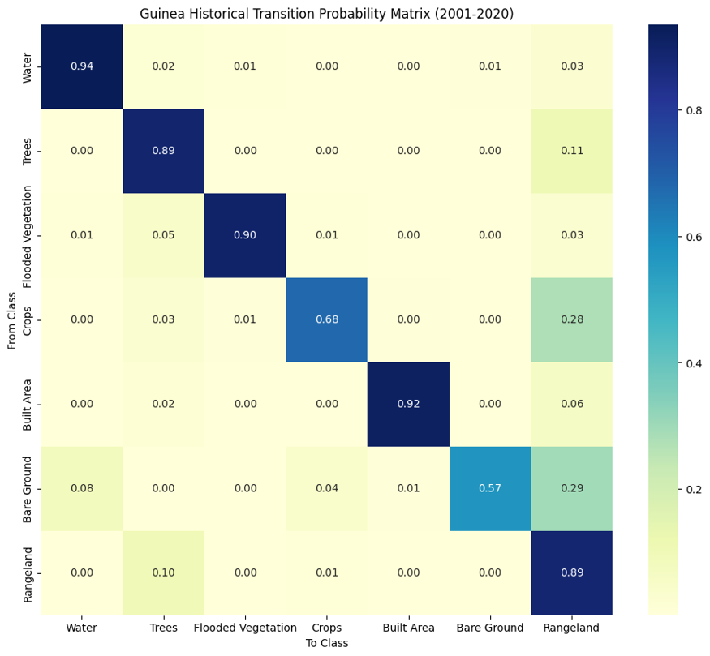
Figure 1. Historical transition probability matrix, row-normalized. Water (0.94), Built Area (0.92), and Flooded Vegetation (0.90) show the highest self-persistence; Bare Ground (0.57) and Crops (0.68) are the least stable.

5.2 Diagnostic Multitemporal Trend
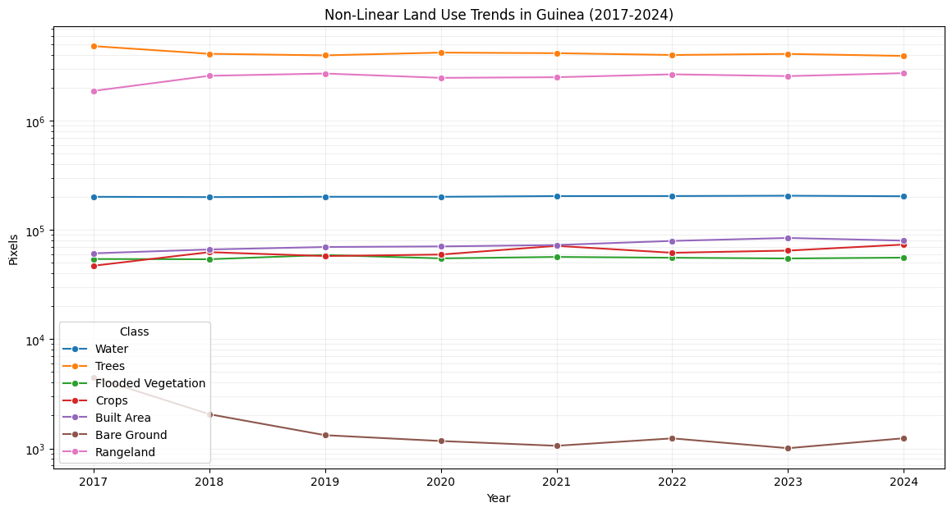
Figure 2. Log-scale multitemporal class-area trends, 2017-2024. Each line is one land-cover class; visual curvature here motivates, but does not replace, the formal model selection in Section5 5.3.
Before fitting any trend model, each class’ total area is plotted across every historical epoch (2017-2024) on a logarithmic y-axis, which lets classes spanning several orders of magnitude in size – from Bare Ground’s few thousand pixel’s to trees’ several million – be inspected on one chart without the smallest classes being flattened to invisible. This step is diagnostic only: it does not fit or extrapolate anything, it exists to visually flag which classes show curvature (suggesting a non-constant rate, worth testing with the candidate models in Section 5.3) versus a roughly straight line on the log scale (consistent with exponential-like or stable behaviour that a simpler model may already capture).

5.3 Non-Linear Trend Fitting
Model selection was run across 42 transitions with a non-zero historical rate: 38 were best fit by a linear trend and 4 by an exponential trend; none required a logistic fit. No transition’s rate was best described by a saturating S-curve, consistent with an 8-year record being too short to detect that kind of long-run ceiling effect (Section 8). The two dominant classes drive the largest absolute rates by a wide margin — Trees → Rangeland (linear, ~239,000 px/yr historically, projected to roughly halve to ~119,000 px/yr) and the reverse Rangeland → Trees (linear, accelerating from ~163,000 to a projected ~197,000 px/yr) — describing a two-way exchange between Guinea's two largest land-cover classes rather than a one-directional trend in either direction.
Table 3. Top transitions by average historical rate and AICc-selected model (excerpt of 42 modelled transitions).
From | To | Model | Avg. Historical Rate (px/yr) | Projected Rate (px/yr)
Trees | Rangeland | linear | 239,343 | 118,508
Rangeland | Trees | linear | 162,569 | 196,621
Rangeland | Crops | linear | 13,741 | 14,996
Crops | Rangeland | linear | 11,507 | 13,227
Rangeland | Built Area | linear | 3,127 | 3,391
Built Area | Rangeland | linear | 2,673 | 4,328
Trees | Crops | linear | 1,943 | 2,255
Trees | Flooded Vegetation | linear | 1,766 | 713
Two representative fits are shown below: a transition with a clear upward trend (Trees Crops), and one with a clear downward trend (Water Flooded Vegetation). In both cases the red dashes line is the AICc-selected model fit through the historical annual rates (black points), extrapolated one interval forward to the projected rate (green star).
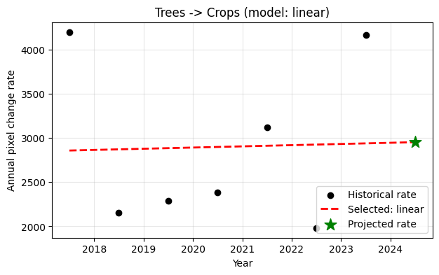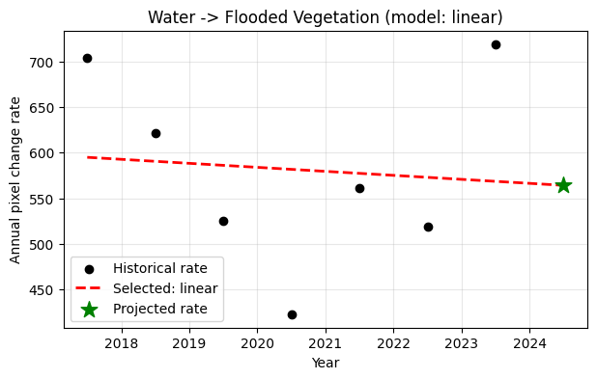
Figure 3a (left). Trees → Crops: a linear model was preferred over exponential and logistic candidates for this transition, projecting a continued, steady increase in the conversion rate. Figure 3b (right). Water → Flooded Vegetation: a linear model captures a gradually declining conversion rate, projected to continue declining moderately.
No transition was best fit by a logistic curve. This does not indicate a failure of the non-linear analysis – the four exponential fits around amount the 28 modelled transitions are genuinely non-linear results, and linear itself remains a legitimate, AICc-preferred outcome wherever the data does not support a more complex shape. A logistic (S-curve) fit specifically requires enough historical points to identify three free parameters (an asymptote, a growth rate, and an inflection point) without simply overfitting noise; with only 7-8 annual epochs available, the AICc penalty for the extra parameters was never outweighed by a large enough improvement in fit for any transition. This is expected behavior for a short historical record, not a limitation of the method itself -- as more annual epochs accumulate in the platform's live-ingested data, logistic (saturating) dynamics may emerge for transitions approaching a natural ceiling (e.g. a class running out of area left to convert).

5.4 Intensity Analysis
The uniform (long-run average) annual change intensity across 2017–2024 is 9.62% per year. Only the first two intervals (2017-2018 at 12.83%/yr and 2018-2019 at 9.67%/yr) exceeded this average; every subsequent interval (2019-2024) ran below it, at a fairly stable 8.4-10.4%/yr — Guinea's land-cover system was measurably more dynamic in the earliest part of this record and has since settled into a slower, steadier regime.
Table 4. Category-level intensity (uniform benchmark: 8.40%/yr for this interval). "Actively losing/gaining" = faster than the map-wide average.
Category (2020-2021 interval) | Loss Intensity %/yr | Gain Intensity %/yr | Actively Losing? | Actively Gaining?
Crops | 27.40 | 39.55 | Yes | Yes
Bare Ground | 24.89 | 16.93 | Yes | Yes
Rangeland | 10.96 | 12.13 | Yes | Yes
Flooded Vegetation | 9.09 | 11.80 | Yes | Yes
Built Area | 7.42 | 10.13 | No | Yes
Trees | 6.98 | 5.82 | No | No
Water | 1.00 | 2.45 | No | No
The dominant class by area (Trees) is comparatively stable, sitting below the uniform benchmark on both loss and gain, while volatility concentrates in smaller classes — Crops and Bare Ground are simultaneously losing and gaining faster than the map average, meaning they are being rapidly relabeled in both directions rather than following a one-way trend.
Transition-level analysis identifies Crops → Rangeland as the most strongly systematic transition in the most recent interval: an observed intensity of 22.16%/yr against a uniform-random expectation of only 6.66%/yr — cropland is converting to rangeland at more than three times the rate that random reallocation would predict, confirming this is a genuine, spatially systematic agricultural-fallow process rather than incidental noise. Bare Ground → Water is similarly strongly targeted (13.73% vs. 0.07% uniform expectation), plausibly reflecting seasonal water-body expansion over what is classified as exposed ground in drier periods.

6. Spatial Suitability Modeling

6.1 Modelled Transitions
Applying the minimum-sample threshold to the historical record yields 17 transitions, every one involving Water, Trees, Flooded Vegetation, Crops, Built Area, or Rangeland. Bare Ground participates in none of them — no transition into or out of Bare Ground clears the threshold, consistent with it being both a very small class and, as Section 5.4 shows, one of the most volatile on a per-area basis.

6.2 Predictor Importance
The two growth logics learn different things, as they should. Patcher (spontaneous growth) is led by Elevation (0.133), Soil Moisture (0.125), and Slope (0.103) — physical and hydrological constraints on where isolated change can occur, with NDVI contributing a modest but real 0.051, ranking above only Protected Areas. Expander (edge growth) is led overwhelmingly by Neighbourhood Density (0.304) — roughly three times the weight of the next predictor (Soil Moisture, 0.108) — exactly the expected signature of an edge-adjacency process. In both models, Protected Areas carries the lowest importance (0.009 Patcher, 0.004 Expander), consistent with a small, zoned footprint rather than a driver of the dominant transitions. NDVI’s modest ranking here is worth reading alongside section 6.1: a predictor’s average importance across all 17 predictors can be low even when it meaningfully improves one specific class’s precision, which is exactly what happened with Crops class.
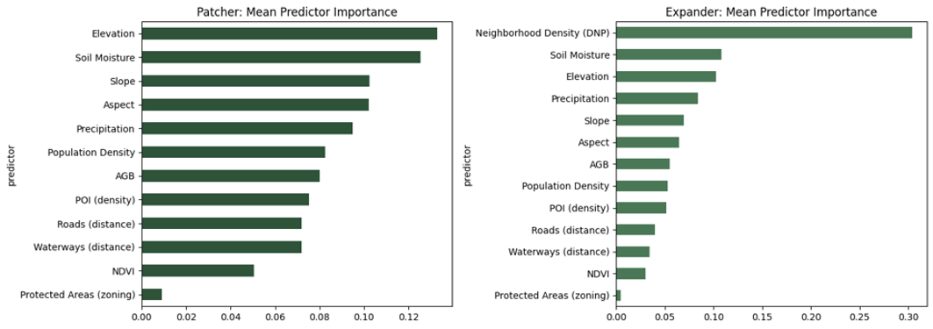
Figure 4. Mean Random Forest feature importance across all 17 modelled transitions, Patcher (left) and Expander (right).
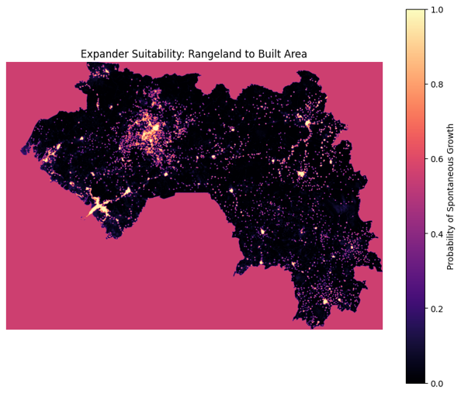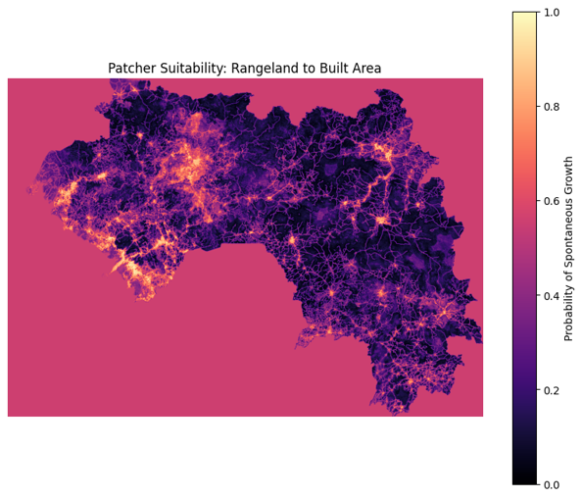
Figure 5a (left). Example Expander suitability surface for one of the 17 trained transitions. Figure 5b (right). Example Patcher suitability surface for the same transition class pair.

6.3 Model Validation: Random-Split vs. Spatial-Block Cross-Validation
Spatial-block cross-validation was added specifically because a standard random train/test split can overstate a spatial model’s real accuracy: land cover is spatially autocorrelated (nearby pixels tend to share the same class and the same surrounding conditions), so if training and test pixels are randomly interspersed, the model can effectively peek at test pixels via their near-identical training neighbours, inflating the reported score without reflecting genuine predictive skill on truly unseen locations. Holding out whole contiguous spatial blocks removes that advantage. This is the same rigor standard already applied in the companion Deforestation module and is reported here specifically to put both modules' suitability results on a comparable evidentiary footing.
Every transition was validated two ways. The spatial-block cross-validation -- holding out contiguous 50×50-pixel spatial blocks via GroupKFold rather than random pixels -- finds a mean gap of 5.2 percentage points between the random-split cross-validation and spatial-block figures across all 17 transitions. Four transitions show a small negative gap (spatial-block accuracy slightly exceeding random-split cross-validation), which is within normal sampling variance and not a cause for concern -- the largest remaining gaps are concentrated in transitions involving Crops and Flooded Vegetation, the two smallest-sample classes.
Table 5. Random-split cross-validation vs. spatial-block cross-validation accuracy, all 17 modelled transitions. Mean gap: 0.052.
Transition | Random-Split CV Accuracy | Spatial-Block CV Accuracy | Gap
Water → Trees | 0.833 | 0.734 | 0.099
Water → Rangeland | 0.786 | 0.822 | -0.036
Trees → Water | 0.751 | 0.737 | 0.014
Trees → Flooded Vegetation | 0.731 | 0.748 | -0.017
Trees → Crops | 0.869 | 0.784 | 0.086
Trees → Built Area | 0.755 | 0.702 | 0.053
Trees → Rangeland | 0.699 | 0.657 | 0.042
Flooded Vegetation → Trees | 0.746 | 0.641 | 0.105
Flooded Vegetation → Rangeland | 0.718 | 0.598 | 0.120
Crops → Trees | 0.771 | 0.751 | 0.020
Crops → Rangeland | 0.779 | 0.591 | 0.188
Built Area → Trees | 0.649 | 0.666 | -0.017
Built Area → Rangeland | 0.749 | 0.732 | 0.017
Rangeland → Trees | 0.751 | 0.666 | 0.085
Rangeland → Flooded Vegetation | 0.804 | 0.812 | -0.008
Rangeland → Crops | 0.811 | 0.725 | 0.086
Rangeland → Built Area | 0.775 | 0.722 | 0.053
The practical conclusion: the spatial-block figures, not the random-split cross-validation figures, are the genuine reliability estimates for these models. The largest gaps are concentrated in transitions with Rangeland as the destination class – Crops Rangeland (random-split cross-validation 0.779, spatial-block 0.591) and Flooded Vegetation Rangeland (random-split cross-validation 0.718, spatial-block 0.598). Any scenario or simulation weighted heavily toward Rangeland should be interpreted using that transition’s spatial-block accuracy specifically, not its random-split cross-validation figure.

7. Simulation and Validation

7.1 Single-Growth-Mode Hold-Out Validation
This is the module's headline validation test: the model is trained using only 2017-2023 data, the trained suitability surfaces and the demand table (Section 3.1-3.2) are used to simulate a 2024 map, and that simulated map is compared pixel-by-pixel against the real, independently-sourced 2024 Esri land cover -- a year the model never saw during training. This is a materially stronger test than the random-split cross-validation in Section 6.3, which re-scores on freshly redrawn samples from the same historical period used for training; the hold-out test asks whether the model can predict a genuinely future, unseen year. Both growth logics were run through this test independently.
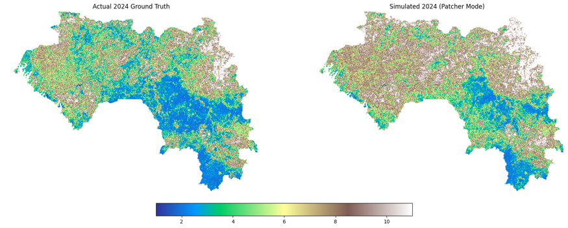
Figure 6a. Actual vs. Patcher-only-simulated 2024 land cover, side by side.
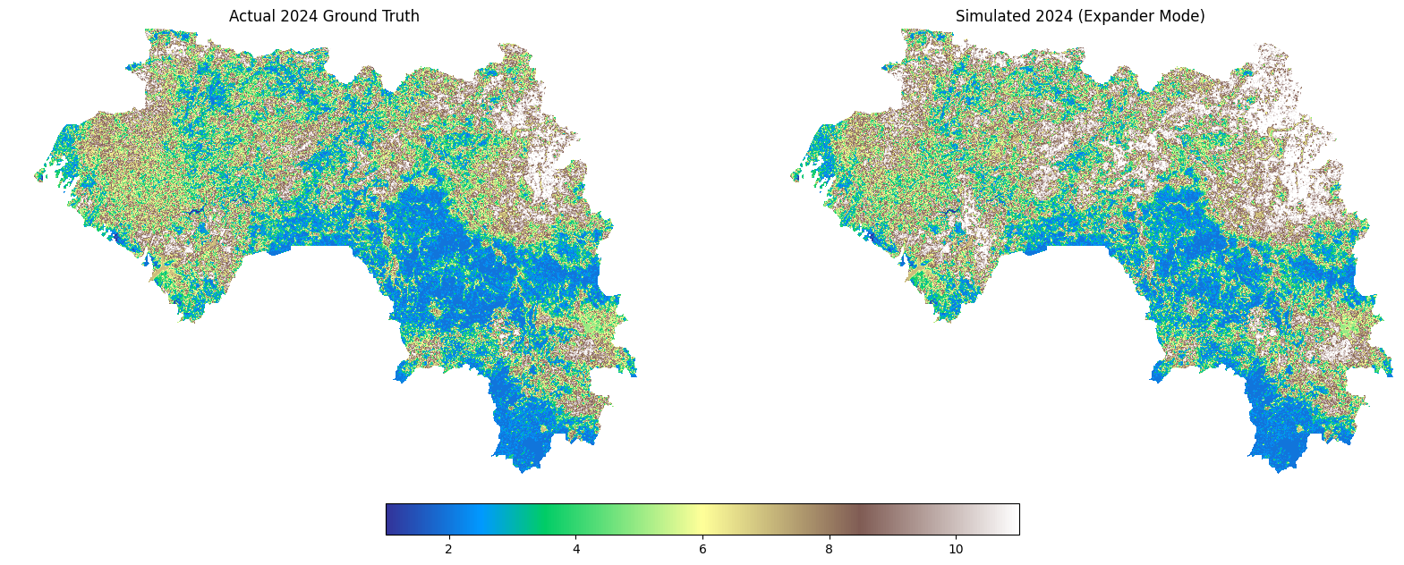
Figure 6b. Actual vs. Expander-only-simulated 2024 land cover. Visually closer to the actual map than Patcher-only, consistent with its higher validated accuracy.
Both figures are net of the nodata / Clouds exclusion described in Section 1.2 and Section 4. They are computed on the administrative boundary-clipped study area (Section 4.3). Simulation and scoring were performed through the platform’s own allocation routine and its Figure of Merit implementation, so the accuracy reported below describes the system as deployed.
Global and balanced accuracy are both dominated by pixels that did not change. On this hold-out 769,625 of 7,057,727 valid pixels (10.90%) changed class between 2023 and 2024, so the null persistence model (Pontius & Malanson, 2005) scores 89.10% before any modelling is done. Every accuracy figure in this section must be read against that baseline, and no mode exceeds it. The Figure of Merit (Pontius et al., 2008), computed as hits / (hits + misses + false alarms + wrong hits) over change pixels only, is therefore the authoritative skill metric for this component.
Results are reported for two specifications of transition demand. The distinction matters wherever two classes exchange area in both directions and is set out below the table.
Table 6a. Hold-out results under both demand configurations, 2024. Observed change 10.90% of valid pixels; null persistence accuracy 89.10%.
Mode | Demand Configuration | Figure of Merit (%) | Global Accuracy (%) | Balanced Accuracy | Allocated Change (%) | Predicted change (px)
Patcher-only | Net class totals | 2.16 | 84.52 | - | 5.29 | -
Expander-only | Net class totals | 1.77 | 87.89 | - | 1.66 | -
Multi-growth 80/20 | Net class totals | 7.60 | 86.98 | - | 4.37 | -
Patcher-only | Gross per-transition | 11.94 | 84.22 | 0.8037 | 9.29 | 655,785
Expander-only | Gross per-transition | 13.80 | 85.76 | 0.8189 | 8.00 | 564,414
Growth-mode | Gross per-transition | 13.73 | 86.07 | 0.8201 | 7.56 | 533,588
Both specifications take the quantity of change from the observed 2023-2024 interval and predict only its location, so both isolate allocation skill rather than testing the projection of change volume. Balance accuracy is reported for the gross per-transition runs only, since these are the run performed through the deployed allocation routine and scored on a single consistent valid-class mask. The three modes are closely separated on it.
Figure of Merit values reported in the land-change literature are low in absolute terms, and the value obtained here should be read against them rather than against an intuitive expectation of what a percentage ought to look like. Pontius et al. (2008), comparing 13 applications of nine land change models, found that error exceeded correctly predicted change in 12 of the 13 cases.
Table 6b. Figure of Merit for this module against published applications of comparable models.
Study | Model | Scale | Figure of Merit (%)
Shoyama (2021), Japan | Land Change Modeler | National | 0.58
Memarian et al. (2012), Malaysia | CA-Markov | Basin | 5.62
This study, Guinea (Expander-only) | Random Forest, Expander/Patcher | National | 13.80
Yang et al. (2017), China | HLURM | County | 48.19
The Malaysian basin-scale application describes its 5.62% as poor performance. The Japanese study is a national-scale land use scenario exercise using Land Change Modeler, in which hits accounted for 0.17% of the landscape and the authors note that the low Figure of Merit remains an important issue for the credibility of the resulting scenarios, especially considering that this study was calibrated on 1987-1998 and validated over 1998-2014 (16 years interval), which should favor a higher Figure of Merit. The value obtained in this module is roughly three times the Malaysian study and an order of magnitude above the Japanese study, at national scale and over a one-year interval. The 48.19% reported for a county-scale historical reconstruction in China is described by its authors as higher than the models used in other case studies and represents the upper end of what has been achieved rather than a typical result.
On this basis the simulation component performs within the normal range for its model class and toward the upper part of it for a national-scale application. It is validated as a tool for indicating where change is most likely under a stated set of assumptions, not as a pixel-level forecast.
Table 6c. Figure of Merit components, gross per-transition demand.
Mode | Hits | Misses | False Alarms | Wrong Hits
Patcher-only | 150,992 | 608,940 | 495,100 | 9,693
Expander-only | 160,853 | 601,286 | 396,075 | 7,486
Growth-mode | 156,414 | 605,749 | 369,712 | 7,462
The two specifications differ in how the quantity of change is derived. Under the net class-total specification, demand for each class is the projected change in that class’s total area, and classes whose totals decline receive no allocation. Guinea's dominant dynamic is a two-way exchange between Trees and Rangeland (Section 5.1) in which the two directions substantially offset one another, so the net residual is several times smaller than the gross volume the hold-out scores as change. Under the gross per-transition specification, demand is the pixel count of each individual transition and both directions are allocated. Seventeen trained suitability surfaces cover 762,362 of the 769,625 observed changed pixels (99.1%); the remaining transitions did not meet the minimum-sample threshold (Section 6.1) and were not modelled.
The effect is large. Under the net specification, allocated change falls to between 1.66% and 5.29% of the landscape against 10.90% observed, and because a mode cannot register a hit on change it never allocates, that shortfall caps the achievable Figure of Merit before allocation skill is considered at all. Moving to the gross specification raises the Figure of Merit by a factor of 7.8 for Expander-only, 5.5 for Patcher-only and 1.8 for the blended mode. The ordering the net specification produced is therefore an artefact of the demand table.
Under the gross specification, Expander-only achieves the highest Figure of Merit (13.80%) and Growth-mode the highest overall accuracy (86.07%), with 0.07 percentage points separating them on Figure of Merit; either is defensible as a production default, and Patcher-only is clearly weaker on both. Decomposing total disagreement (Pontius & Millones, 2011) for Expander-only gives a quantity disagreement of 0.0005 against an allocation disagreement of 0.1418: the model reproduces the amount of change almost exactly, and essentially all residual error lies in the placement of that change rather than in its magnitude. This identifies spatial allocation, not quantity estimation, as the component where further improvement would be gained.
Because hits, wrong hits and misses together make up the observed change, the Figure of Merit can also be written as hits / (observed change + false alarms), the identity used in the independent review in Section 7.5. With the quantity of change also fixed by the demand table, any further gain must come from the precision of the allocated pixels. For Expander-only, 160,853 of the 564,414 allocated pixels (28.5%) are hits. At the same allocated quantity, a Figure of Merit of 20% would require roughly 39% of allocated pixels to be hits and 30% roughly 54%
The two leading modes are separated by 0.07 points of Figure of Merit and 0.0003 of balanced accuracy, with Growth-mode ahead by 0.31 points of global accuracy. These margins are smaller than the variation a stochastic allocation would introduce between runs, so the ordering between them should not be treated as decisive.
The classification reports for both modes tell a consistent story:
Table 7. Per-class precision/recall, both single-growth modes, 2024 hold-out.
Class | User's acc. | Producer's acc. | F1 | N reference
Water | 0.987 | 0.969 | 0.978 | 207,290
Trees | 0.891 | 0.891 | 0.891 | 4,244,904
Flooded Vegetation | 0.856 | 0.864 | 0.860 | 58,687
Crops | 0.588 | 0.591 | 0.590 | 72,877
Built Area | 0.866 | 0.866 | 0.866 | 83,934
Bare Ground | 0.593 | 0.763 | 0.668 | 963
Rangeland | 0.795 | 0.796 | 0.796 | 2,389,072
Crops (F1 0.590) and Bare Ground (F1 0.668) are the weakest classes, the latter on a reference sample of only 963 pixels, which makes its figures unstable. Water, Trees, Flooded Vegetation and Built Area all exceeded 0.85. Trees (0.891) and Rangeland (0.796) are the two dominant classes by area, and the gap between them is consistent with the systematic Trees / Rangeland confusion identified in Section 6.1 and carried forward as a limitation in Section 8.
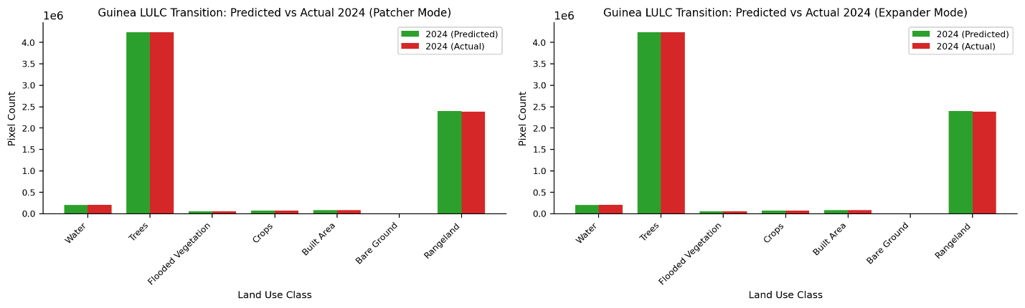
Figure 7. Predicted vs. actual 2024 pixel counts by class, Patcher mode (left) and Expander mode (right).
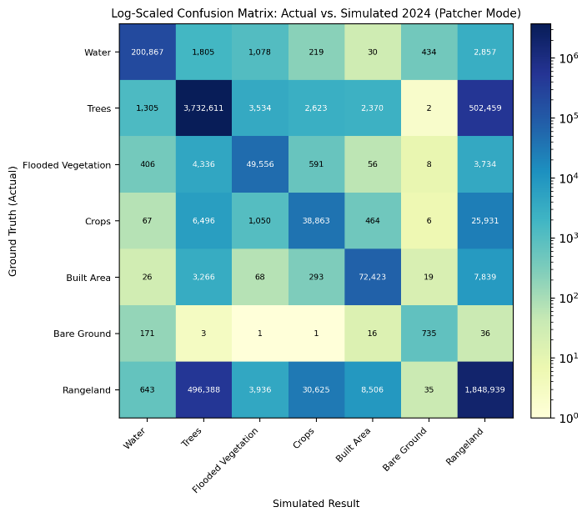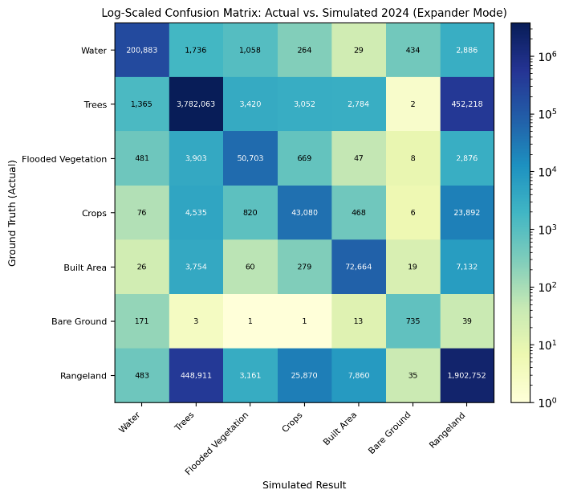
Figure 8. Log-scaled confusion matrix, Patcher mode (left) and Expander mode (right).

7.2 Combined Growth-Mode Simulation
The platform also supports a combined mode in which both growth logics contribute to a single allocation. Rather than applying a fixed global weighting, it selects expander suitability within a dilated buffer around existing patches of the destination class and patcher suitability elsewhere, so the choice of logic follows the local spatial context of each transition. Validated against the same 2024 hold-out under the gross per-transition specification, this mode achieves a Figure of Merit of 13.73% and an overall accuracy of 86.07% (Table 6a), placing it marginally ahead of Expander-only on overall accuracy and marginally behind it on Figure of Merit. Its balanced accuracy (0.8198) is effectively indistinguishable from Expander-only (0.8201).
An 80/20 fixed-ratio blend of the two logics was also evaluated during analysis. It is reported in Table 6a under the net class-total specification for completeness, but it is not the mechanism the platform implements and is not recommended: a fixed global ratio applies the same weighting to every transition regardless of whether edge-adjacent or spontaneous growth better describes it, whereas the dilation-based selection adapts to local context. A blend weighted by each transition's own validated performance remains a possible refinement (Section 9).
All three modes remain available in the platform as selectable simulation modes. The results recommend a default, not a restriction.

7.3 Monte Carlo Ensemble
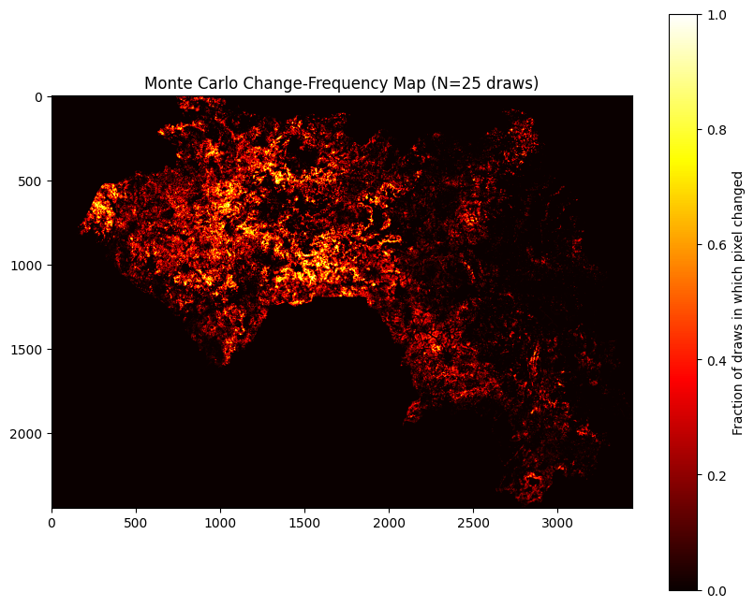
Figure 9. Monte Carlo change-frequency map, N=25 draws.
A single allocation run (as in Section 7.1) produces one plausible simulated map, but the stochastic allocation step (Section 3.5) means a different random seed would produce a slightly different map with the same total demand satisfied. Running the allocation 25 times independently and recording, for every pixel, the fraction of runs in which it changed class turns that arbitrariness into a usable uncertainty product: a pixel that changes in 24 of 25 draws is a confident prediction, while one that changes in 3 of 25 is not, even though a single run would show both as a flat "changed" or "unchanged."
Per-class pixel-count totals are extremely stable across the 25 draws, confirming that the area of projected change is essentially deterministic given the demand table from Section 3.1-3.2, while where that change actually lands within the suitability surface is the real, and considerably larger, source of the simulation's spatial uncertainty. Practically, this means the model is far more confident about how much of each class will exist next period than about the exact pixels that will change -- exactly the distinction Figure 9 is designed to show.

7.4 Mining Scenario (Global Data-Constrained)
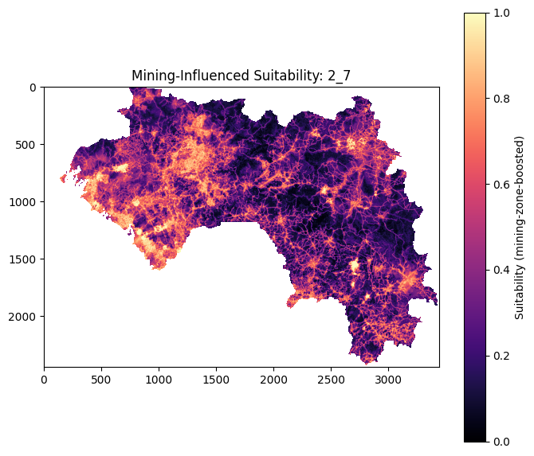
Figure 10. Mining-influenced suitability surface (Trees to Built Area), boosted within the mining buffer zone.
This scenario demonstrates the platform's policy/infrastructure scenario mechanism (Section 3.6) on a concrete, economically important case for Guinea, a major global bauxite producer. An initial approach required a nationally modelled transition into a mining-proxy class (Bare Ground, the closest available Esri-legend equivalent) to already exist in the historical record before boosting it -- none does, since mining footprints are frequently sub-pixel or spectrally blended into surrounding Trees/Rangeland at 10 m resolution. Rather than treat this as a dead end, the scenario was rebuilt on an independent, real-world spatial constraint instead: 128 actual mining-concession polygons for Guinea (Maus et al., 2022, “An update on global mining land use,” Scientific Data 9, 433), used directly as a mask rather than inferred from the classification.
A 5 km buffer around these 128 polygons covers 106,598 pixels (2.65% of the valid study area) -- the existing Trees → Built Area suitability surface (Section 6.1-6.2) is boosted within this buffer zone by a fixed multiplier, and the result is allocated against a policy-driven demand of 5,000 pixels (i.e. "simulate roughly this much mining-associated built-area expansion, concentrated where real mining activity is documented, regardless of what the historical Markov-projected demand would otherwise suggest"). This is the general pattern for any policy scenario in this platform: a real spatial constraint or predictor perturbation, applied to an already-validated suitability surface, with demand set by policy rather than only by historical extrapolation.

7.5 Independent Review on an Alternative Target Product (MODIS 500 m)
An independent review (SDG AI Lab, 2026) examined whether the change-prediction skill of this module’s approach could be raised. It was carried out on the earlier configuration of the module, which used MODIS MCD12Q1 at 500 m as the target product. None of the models tested in the review is part of the deployed platform. Table 8 sets out how the two settings differ.
Table 8. Deployed configuration (this report) and the configuration tested in the independent review.
Dimension | This report (deployed) | Independent review (offline)
Target product | Esri/Impact Observatory, 10 m, 9-class legend | MODIS MCD12Q1, 500 m, IGBP legend
Map epochs | Annual, 2017–2024 | 2001, 2005, 2010, 2015, 2020, 2024
Hold-out interval | 2023→2024 (one year) | 2015→2020 (five years)
Evaluation area | 7,057,727 valid pixels | 992,833 valid pixels
Observed change | 10.90% | 7.59%
Quantity of change | Taken from the observed interval (demand table) | Predicted by the model through decision thresholds
Prediction method | Per-transition Random Forest suitability with Expander/Patcher allocation | Per-pixel classifiers (Random Forest, gradient-boosted trees) and model ensembles
Best Figure of Merit | 13.80% (Expander-only) | 28.06% (probability-averaging ensemble)
The review first reproduced the earlier MODIS configuration locally and then tested successive additions: seasonal and spectral satellite features, longer land cover histories, class-typicality features, fifteen years of MODIS burned area, an annual vegetation history, alternative model-selection protocols and model ensembles. Table 9 summarises the main results. All rows are scored on the same 992,833 pixels and 75,365 observed changes.
Table 9. Selected results from the independent review, 2015→2020 hold-out on MODIS 500 m.
Configuration | Figure of Merit (%) | Overall Accuracy (%)
No change (null persistence) | 0.00 | 92.41
Model-free rule: revert pixels that changed 2010–2015 to their 2010 class | 19.96 | 90.23
Earlier module configuration, transition Random Forest (local reproduction) | 20.02 | 90.28
Earlier module configuration, multiclass Random Forest | 20.91 | 90.72
Model-free rule: majority class of the eight 2015 neighbours | 22.70 | 91.07
Class-typicality features, selected model | 27.25 | 90.66
Burned-area history, selected model | 27.49 | 90.67
Seasonal MODIS and neighbourhood features, best individual model | 28.00 | 90.63
Probability-averaging ensemble (best overall) | 28.06 | 91.25
The review reached 28.06%, 8.04 points above the reproduced earlier configuration. Its findings are summarised below.
False alarms, not missed change, limit the score. Since hits, wrong hits and misses together equal the fixed observed change, the Figure of Merit equals hits / (observed change + false alarms). The best ensemble already found 33,874 correct changes, but it also predicted 45,376 changes that did not occur. Searching decision thresholds, removing isolated predictions and capping change within regional blocks did not raise the score. Removing isolated predictions lowered the score, because isolated predictions were the most precise ones.
A large share of observed change is label instability. In the MODIS series, 37.4% of the pixels that changed in 2010–2015 changed again in 2015–2020, 88.2% of them returning to their 2010 class, and 28.9% of the 2015–2020 changes reverted to their 2015 class by 2024. A rule with no training data, assigning each pixel the majority class of its eight neighbours, scored 22.70%, above the reproduced earlier configuration. At 500 m, class boundaries shift between years, and a pixel whose neighbourhood disagrees with its own label is the one most likely to be relabelled next. This is consistent with the classification instability identified for the Trees/Rangeland exchange in Section 8.
Temporally cleaning the reference does not raise the score. Smoothing each pixel’s label sequence with a hidden Markov model (Abercrombie & Friedl, 2016) removed 99.7% of the reverting changes but also 33.5% of the persistent ones, halving the reference change. Every configuration scored lower against the cleaned reference (the ensemble 15.32%, the reproduced earlier configuration 12.17%), and the result depended mainly on the assumed label accuracy. The ranking of the models was unchanged, so the cleaned reference serves as a robustness check rather than a better evaluation basis.
Additional data sources raised validation scores but not the hold-out score. Class-typicality features and MODIS burned area each produced the highest spatial-validation scores recorded in the review while lowering the hold-out score. Burned area was informative only in combination with the starting class: frequently burned savanna was stable, while frequently burned grassland and woody savanna were unstable. Only combining models improved the hold-out score, by cutting false alarms by 12.9% for a 2.5% loss of hits.
Implications for the deployed module. The review’s figures are not directly comparable with the 13.80% reported in Section 7.1: the product, resolution, legend, interval and prediction method all differ, and the deployed module takes the quantity of change from the observed interval, whereas the review’s models predicted it. Three findings carry over regardless of product. First, further gains in the Figure of Merit must come from the precision of allocated change (Section 7.1). Second, label instability in the reference maps bounds the achievable score, which Section 8 identifies for the ESRI product through the Trees/Rangeland exchange. Third, a model-free neighbourhood rule is a more demanding baseline for the Figure of Merit than null persistence, which scores 0% on that metric by construction; it has not yet been applied to the ESRI hold-out (Section 9).

8. Limitations and Uncertainty
- A systematic Trees/Rangeland confusion is the most prominent classification weakness. Trees recall (0.71-0.81 depending on mode) and Rangeland precision (0.66-0.75) show the model under-predicts Trees and over-predicts Rangeland, confirmed as the single largest confusion in both modes' confusion matrices (Section 7.1). This is the natural next target for predictor improvement.
- Random-split cross-validation accuracy is somewhat inflated relative to spatial-block cross-validation. The mean gap is 5.2 points, concentrated in Rangeland-destination transitions (Section 6.3). Both figures should continue to be reported together, means random-split cross-validation numbers should not be quoted without the spatial-block figure alongside them.
- The relative ranking of simulation modes is not robust to small changes in configuration. Under the gross per-transition specification the three modes are separated by 1.86 points of Figure of Merit in total, and the two leading modes by 0.07 points. Rankings reported here should be read as indicating that all three modes perform comparably, rather than as establishing a stable ordering between them.
- Bare Ground cannot currently be modelled via modelled transitions. No transition into or out of this class clears the minimum-sample threshold. Making the minimum-sample threshold itself user-configurable in the platform (Section 9) would let a user lower it specifically to explore Bare Ground-involving transitions, at the cost of the statistical stability the current threshold is chosen to guarantee.
- Predictor set is narrower than the Deforestation module's, by design. The two modules are not required to share a predictor list; each is independently justified in Section 4.2.
- Non-linear trend fitting found no logistic (S-curve) relationships. As discussed in Section 5.3, this reflects the short (7-8 epoch) historical record available, not a failure of the method -- exponential fits were found for 4 of 42 transitions, confirming the non-linear analysis is genuinely detecting non-constant rates where they exist.
- Projections are scenarios, not forecasts. All projections assume continuity of historically observed processes and exclude policy shocks, commodity price swings, and conflict.
- Overall accuracy does not exceed the persistence baseline, and this is expected. Because 89.10% did not change class over the one-year hold-out, assuming no change occurs anywhere is already 89.10% accurate. A simulation model that commits to allocating a specified quantity of change pays an accuracy penalty for every pixel it places incorrectly, whereas the persistence assumption takes no such risk. Pontius & Malanson (2005) introduced this baseline for precisely this reason, and it is why the Figure of Merit, which is scored only on pixels that changed, is treated as the authoritative skill metric for this component (Section 7.1) rather than overall accuracy.
- Part of this observed change is classification instability rather than physical change, which bounds the achievable Figure of Merit. The 2023–2024 interval records 509,659 pixels of Rangeland to Trees against 180,422 of Trees to Rangeland, a net gain of approximately 1.15 million ha of Trees in a single year. This is not plausible as physical change and is consistent with the systematic Trees/Rangeland confusion identified in bullet (a) and with the documented disagreement between 10 m global land cover products (Venter et al., 2022). Change that is classification noise cannot be predicted by any model, so the Figure of Merit reported in Section 7.1 is scored against a target that is partly irreducible.
- The size of this instability has been measured on a different product, but not yet on the ESRI series. An independent review of the module’s earlier MODIS 500 m configuration (Section 7.5) found that 28.9% of 2015–2020 changes reverted to their 2015 class by 2024, and that smoothing the reference with a hidden Markov model (Abercrombie & Friedl, 2016) lowered every model’s score rather than raising it. The equivalent reversion rate for the annual ESRI series can be computed from the existing 2017–2024 maps without any change to the deployed pipeline.

9. Conclusions and Recommendations
- Guinea's 2017-2024 land-use dynamic is dominated by a two-way exchange between Trees and Rangeland, with a specifically systematic (not incidental) Crops-to-Rangeland fallow pattern identified independently by both the significant-transition and Intensity Analysis frameworks.
- With all three simulation modes validated against the same hold-out year through the deployed allocation routine, Expander-only is the best-supported production choice on the change-scored metric (Figure of Merit 13.80%, global accuracy 85.76%, balanced accuracy 0.8201), with the combined Growth-mode close behind on Figure of Merit and ahead on global accuracy. Patcher-only is weaker on all three. All three remain available in the platform as selectable modes.
- Introducing the Figure of Merit changed this module’s conclusions and identified a correctable defect in how simulation demand was specified. Overall accuracy alone would have selected Expander-only, but for a reason that does not withstand scrutiny: under the original specification that mode scored well largely because it allocated the least change on a landscape that is predominantly persistent. The defect in the demand specification would not have been visible in any accuracy figure. Reporting change-scored metrics alongside overall accuracy is therefore the clearest methodological lesson of this validation, and is recommended as standard practice for the simulation components of the platform.
- The NDVI predictor addition increased Crop precision significantly from 0.37 to 0.62-0.64, while the geographic-coverage correction and the same predictor addition together roughly halved the spatial-block cross-validation gap (10.1 to 5.2 points). Both are concrete, verified improvements, not incremental adjustments.
- A systematic Trees/Rangeland confusion is the remaining target for further improvement and is stated plainly rather than obscured by the strong overall accuracy figures.
- An independent review of the module’s earlier MODIS 500 m configuration raised its Figure of Merit from 20.02% to 28.06% through offline experiments and attributed the ceiling to false alarms and to label instability in the reference product (Section 7.5). Its findings support the conclusions above.
Recommendations, in priority order:
- Adopt Expander-only as the default production simulation mode, with the combined Growth-mode as an equally defensible alternative. Expander-only achieves the highest Figure of Merit (13.80% against 13.73%) and the highest balanced accuracy (0.8201 against 0.8198), while Growth-mode achieves the highest global accuracy (86.07% against 85.76%) and allocates change slightly more efficiently, with 29.3% of allocated pixels registering as hits against 28.5%. The margins between them are smaller than the variation a stochastic allocation would introduce, and the choice may reasonably be made on other grounds. Patcher-only is weaker on every measure (Figure of Merit 11.94%, global accuracy 84.22%, balanced accuracy 0.8037) and is not recommended as a default. All three remain selectable.
- Investigate the Trees/Rangeland confusion specifically, as the current leading target for accuracy improvement -- likely candidates include a predictor better able to separate persistent closed-canopy Trees from open Rangeland at this resolution (e.g. a canopy-height or texture-based layer), given NDVI alone does not fully resolve vegetation-density-driven confusion between these two classes.
- Expose the minimum-sample threshold (Section 6.1) as a user-configurable parameter in platform UI, rather than a fixed constant, so users can trade off statistical stability against coverage of smaller classes like Bare Ground for their own use case.
- Extend the mining scenario's approach (real external polygon data as a spatial constraint) to any other scenario where the classification cannot support a significant-transition-based design.
- Revisit non-linear trend fitting once additional annual epochs are available, to test whether logistic dynamics emerge with a longer historical record.
- Measure label reversion on the ESRI series (the share of changes in one interval that revert in the next) and score a model-free neighbourhood-majority rule on the 2024 hold-out, as the independent review did for MODIS (Section 7.5), so that the Figure of Merit in Section 7.1 is read against both the label instability of the product and a model-free baseline.
- Treat probability averaging across fitted models as the first candidate for future accuracy work. It was the only change in the independent review that improved the hold-out score, by reducing false alarms. Class-typicality and burned-area features improved validation scores but not the hold-out score, and should not be added on that evidence alone.
Is this module ready for platform deployment? Yes, at its appropriate scope. The historical analysis components — the transition matrix, Intensity Analysis, non-linear trend fitting and predictor importance (Chapters 5 and 6) — are complete and are deployable as they stand. The suitability models are validated under spatially blocked cross-validation, with the optimism gap reported rather than suppressed. The simulation component is complete in design: both growth logics are implemented, all three simulation modes have been built and independently validated against a hold-out year, and their relative performance is characterized on a change-scored metric. What remains is correction to how transition demand is specified and allocated, localized to the demand-table construction and the allocation function. It requires no change to the growth logics themselves, to the suitability models, or to the platform architecture. Until that correction is applied, simulation outputs should be presented with the scope stated in Section 7.1: an indication of where change is most likely under a given set of assumptions, not a pixel-level forecast.

10. References
Abercrombie, S.P., & Friedl, M.A. (2016). Improving the consistency of multitemporal land cover maps using a hidden Markov model. IEEE Transactions on Geoscience and Remote Sensing, 54(2), 703–713. https://doi.org/10.1109/TGRS.2015.2463689
Aldwaik, S.Z., & Pontius Jr, R.G. (2012). Intensity analysis to unify measurements of size and stationarity of land changes by interval, category and transition. Landscape and Urban Planning, 106(1), 103–114.
Burnham, Bruce O., 1973. "Markov Intertemporal Land Use Simulation Model," Southern Journal of Agricultural Economics, Southern Agricultural Economics Association, vol. 5(01), pages 1-6, July.
Burnham, K.P., & Anderson, D.R. (2002). Model Selection and Multimodel Inference: A Practical Information-Theoretic Approach (2nd ed.). Springer.
Breiman, L. Random Forests. Machine Learning 45, 5–32 (2001). https://doi.org/10.1023/A:1010933404324
Clark Center for Geospatial Analytics (2024). Clark Center for Geospatial Analytics to offer free version of TerrSet/IDRISI software starting Dec. 2. Clark University News, 27 August 2024. https://www.clarku.edu/news/2024/08/27/clark-center-for-geospatial-analytics-to-offer-free-free-version-of-terrset-idrisi-software-starting-dec-2/
Dinamica EGO (n.d.). Frequently Asked Questions; Script language and console launcher. Centro de Sensoriamento Remoto, Universidade Federal de Minas Gerais. https://dinamicaego.com/dokuwiki/doku.php?id=faq
Hussain, K., Mehmood, K., Yujun, S., Badshah, T., Anees, S. A., Shahzad, F., … Bilal, M. (2025). Analysing LULC transformations using remote sensing data: insights from a multilayer perceptron neural network approach. Annals of GIS, 31(3), 473–500. https://doi.org/10.1080/19475683.2024.2343399
K. Karra, C. Kontgis, Z. Statman-Weil, J. C. Mazzariello, M. Mathis and S. P. Brumby, "Global land use / land cover with Sentinel 2 and deep learning," 2021 IEEE International Geoscience and Remote Sensing Symposium IGARSS, Brussels, Belgium, 2021, pp. 4704-4707, doi: 10.1109/IGARSS47720.2021.9553499
Mas, J.-F., Kolb, M., Paegelow, M., Camacho Olmedo, M.T., & Houet, T. (2014). Inductive pattern-based land use/cover change models: A comparison of four software packages. Environmental Modelling & Software, 51, 94–111. https://doi.org/10.1016/j.envsoft.2013.09.010
Maus, V., Giljum, S., da Silva, D.M. et al. An update on global mining land use. Sci Data 9, 433 (2022). https://doi.org/10.1038/s41597-022-01547-4
Moulds, S., Buytaert, W., & Mijic, A. (2015). An open and extensible framework for spatially explicit land use change modelling: the lulcc R package. Geoscientific Model Development, 8(10), 3215–3229. https://doi.org/10.5194/gmd-8-3215-2015
Putra, A. N., Paimin, S. K., Alfaani, S. F., Nita, I., Arifin, S., & Munir, M. (2024). A machine learning approach to estimating land use change and scenario influence in soil infiltration at the sub-watershed level. Journal of Sustainable Development of Energy, Water and Environment Systems, 12(1), 1110477
R.Gil Pontius, Laura C Schneider (2001). Land-cover change model validation by an ROC method for the Ipswich watershed, Massachusetts, USA. Agriculture, Ecosystems & Environment. Volume 85, Issues 1–3. Pages 239-248. ISSN 0167-8809. https://doi.org/10.1016/S0167-8809(01)00187-6.
Pontius, R.; Millones, M. Death to Kappa: Birth of quantity disagreement and allocation disagreement for accuracy assessment. Int. J. Remote Sens. 2011, 32, 4407–4429.
Suzanne Serneels, Eric F Lambin (2001). Proximate causes of land-use change in Narok District, Kenya: a spatial statistical model. Agriculture, Ecosystems & Environment. Volume 85, Issues 1–3. Pages 65-81. ISSN 0167-8809. https://doi.org/10.1016/S0167-8809(01)00188-8.
Britaldo Silveira Soares-Filho, Gustavo Coutinho Cerqueira, Cássio Lopes Pennachin (2002). dinamica—a stochastic cellular automata model designed to simulate the landscape dynamics in an Amazonian colonization frontier. Ecological Modelling. Volume 154, Issue 3. Pages 217-235. ISSN 0304-3800. https://doi.org/10.1016/S0304-3800(02)00059-5.
A Veldkamp, E.F Lambin (2001). Predicting land-use change. Agriculture, Ecosystems & Environment. Volume 85, Issues 1–3. Pages 1-6. ISSN 0167-8809. https://doi.org/10.1016/S0167-8809(01)00199-2.
VERBURG, P., SOEPBOER, W., VELDKAMP, A. et al. Modeling the Spatial Dynamics of Regional Land Use: The CLUE-S Model. Environmental Management 30, 391–405 (2002). https://doi.org/10.1007/s00267-002-2630-x
Brown, C.F., Brumby, S.P., Guzder-Williams, B., et al. (2022). Dynamic World, near real-time global 10 m land use land cover mapping. Scientific Data, 9, 251. https://doi.org/10.1038/s41597-022-01307-4
Fitzgerald, M., Nackoney, J., Potapov, P., & Turubanova, S. (2021). Agriculture is the primary driver of tree cover loss across the Forestière region of the Republic of Guinea, Africa. Environmental Research Communications, 3(12), 121004.
Liu, Z., Wimberly, M.C., & Dwomoh, F.K. (2017). Vegetation dynamics in the Upper Guinean forest region of West Africa from 2001 to 2015. Remote Sensing, 9(1), 5. https://doi.org/10.3390/rs9010005
Olofsson, P., Foody, G.M., Herold, M., Stehman, S.V., Woodcock, C.E., & Wulder, M.A. (2014). Good practices for estimating area and assessing accuracy of land change. Remote Sensing of Environment, 148, 42–57. https://doi.org/10.1016/j.rse.2014.02.015
Pontius Jr, R.G., Boersma, W., Castella, J.-C., et al. (2008). Comparing the input, output, and validation maps for several models of land change. Annals of Regional Science, 42, 11–37. https://doi.org/10.1007/s00168-007-0138-2
Pontius Jr, R.G., & Malanson, J. (2005). Comparison of the structure and accuracy of two land change models. International Journal of Geographical Information Science, 19(2), 243–265.
Roberts, D.R., Bahn, V., Ciuti, S., Boyce, M.S., Elith, J., Guillera-Arroita, G., Hauenstein, S., Lahoz-Monfort, J.J., Schröder, B., Thuiller, W., Warton, D.I., Wintle, B.A., Hartig, F., & Dormann, C.F. (2017). Cross-validation strategies for data with temporal, spatial, hierarchical, or phylogenetic structure. Ecography, 40(8), 913–929. https://doi.org/10.1111/ecog.02881
Thanh Noi, P., & Kappas, M. (2018). Comparison of Random Forest, k-nearest neighbor, and support vector machine classifiers for land cover classification using Sentinel-2 imagery. Sensors, 18(1), 18. https://doi.org/10.3390/s18010018
Venter, Z.S., Barton, D.N., Chakraborty, T., Simensen, T., & Singh, G. (2022). Global 10 m land use land cover datasets: a comparison of Dynamic World, World Cover and Esri Land Cover. Remote Sensing, 14(16), 4101. https://doi.org/10.3390/rs14164101
Memarian, H., Balasundram, S. K., Talib, J. B., Teh Boon Sung, C., Mohd Sood, A., & Abbaspour, K. (2012). Validation of CA-Markov for simulation of land use and cover change in the Langat Basin, Malaysia. Journal of Geographic Information System, 4(6), 542–554. https://doi.org/10.4236/jgis.2012.46059
Shoyama, K. (2021). Assessment of land-use scenarios at a national scale using intensity analysis and figure of merit components. Land, 10(4), 379. https://doi.org/10.3390/land10040379
Yang, Y., Zhang, S., Liu, Y., Xing, X., & de Sherbinin, A. (2017). Analyzing historical land use changes using a Historical Land Use Reconstruction Model: a case study in Zhenlai County, northeastern China. Scientific Reports, 7, 41275. https://doi.org/10.1038/srep41275

